|  |  |  |  |
| --- | --- | --- | --- |
| UMass-Lowell-logo.png (295×358) | **Graphical Circuit Analysis**  **via Fourier Transforms** | |  |
|  | |  |
| Joseph Taylor  Thomas Tawadros | | |
| Signals and Systems  EECE 3620 - 201 | | |
|  | | |
|
|  |

**Introduction - Plots of Provided Source Signals**

*Figure 1 – Plot of Current versus Time for Device 1*

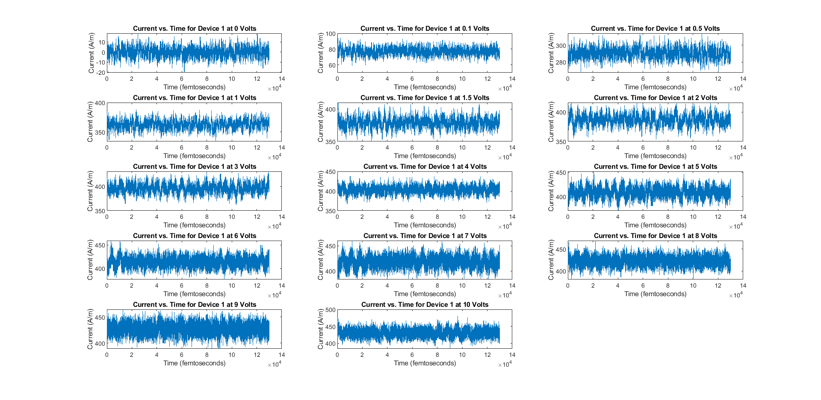

*Figure 2 – Plot of Current versus Time for Device 2*

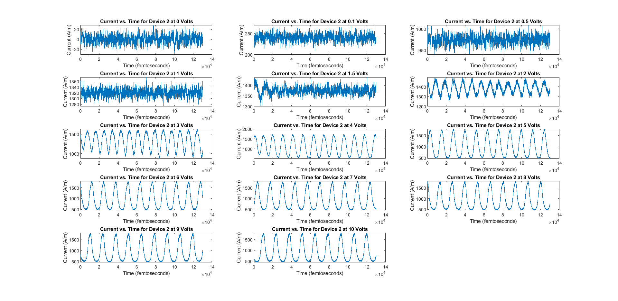

**Note: Frequency of Device 2 at 7 V $=\frac{1}{Period}=\frac{1}{\frac{12}{9}*10^{4}/10^{15}}=7.5*10^{10}$ Hz**

1. **Current-Voltage (I-V) Characteristics**

*Figure 3 – Plot of Average Current versus Voltage for Devices 1 and 2*

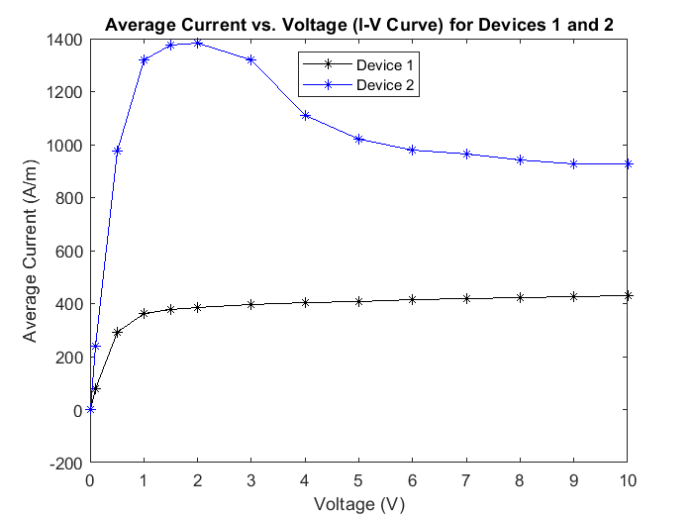

Evaluating the plot depicted in *Figure 3 – Plot of Average Current versus Voltage for Devices 1 and 2***,** there exist a few significant differences between Device 1 and Device 2 regarding their average current values across the provided range of voltages. Device 1 has a lower average current at all voltage levels, and takes on an exponentially slowing increase in average current as the voltage is increased. Device 2, to the contrary, has a higher and more sporadic current value, which starts off nearly vertical but crests a “hill” at 2 volts and settles down to about 1000 A/m. Regardless of these differences, both characteristic curves showcase a leveling off of current despite increases in voltage. The major contrast between the two is that the current of Device 2 rises much higher than Device 1 before decreasing and behaving asymptotically.

1. **Calculation of Fourier Transforms**

*Figure 4 – Current versus Frequency of Device 1*

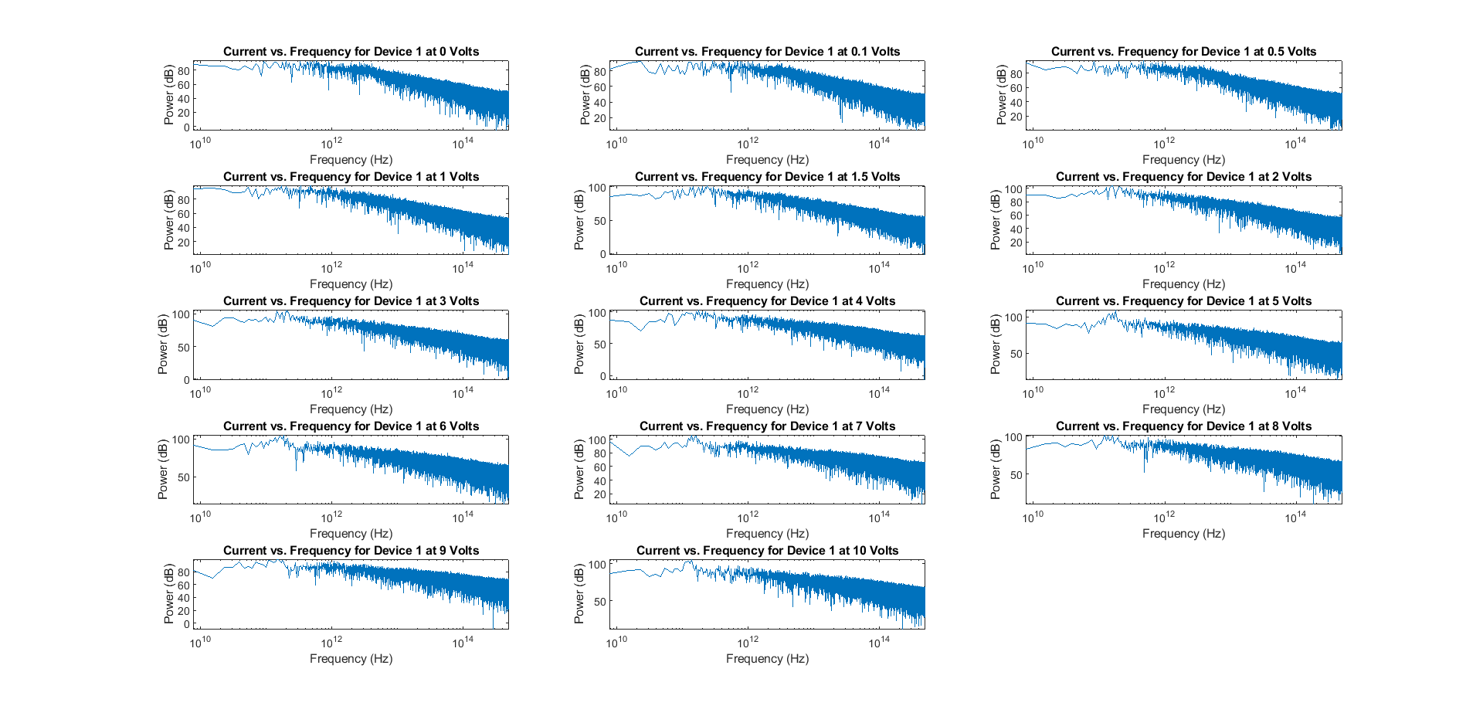

Looking at this graph, we can see that the peak in frequency is somewhere in the 1011 Hz range for most voltage levels. Compared to Device 2, this is a much less obvious peak frequency.

*Figure 5 – Current versus Frequency of Device 2*

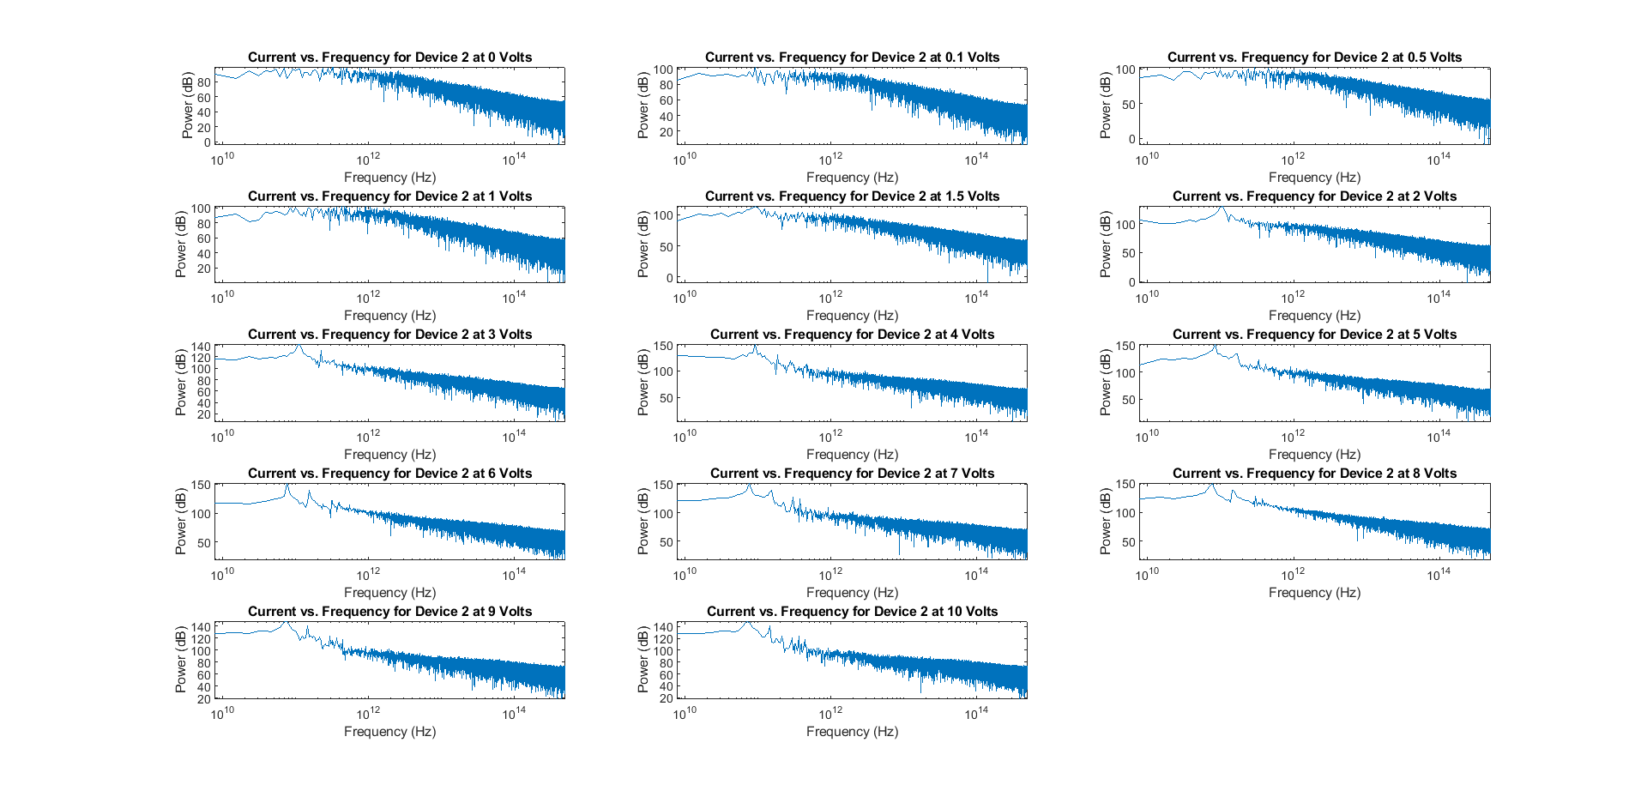

Looking at these graphs, we can see that they take the same basic shape as the Device 1 graphs. However, there is a much better-defined peak in frequency at about 7.5 x 1010 Hz. This is perfectly in line with the visually calculated frequency from Figure 2.

*Figure 6 - Plot of Frequency versus Voltage of Devices 1 and 2*

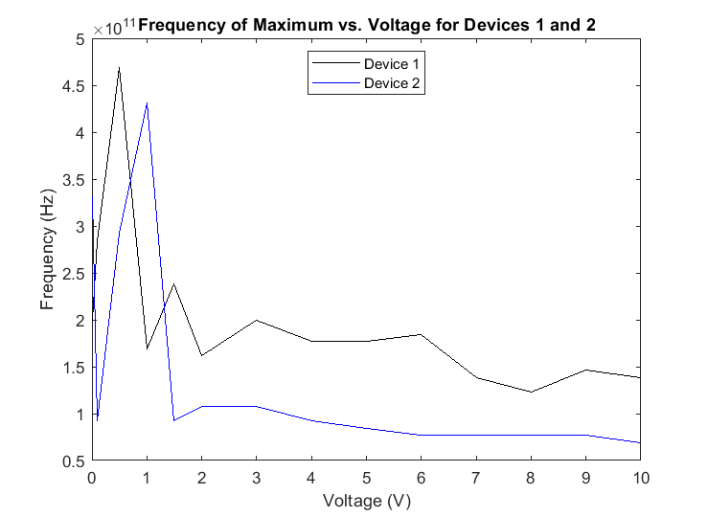

The plot depicted in *Figure 6 - Plot of Frequency versus Voltage of Devices 1 and 2,* confirms the previously noted trends as demonstrated in the previous figures. In *Figure 2 – Plot of Current versus Time for Device 2*, there exists a sinusoidal waveform in Device 2 with a frequency of about 7.5 x 1010 Hz. Upon calculating the Fourier transform of Device 2 and plotting it on a log scale, a peak is present at roughly the same frequency of 7.5 x 1010 Hz. In this final graph, it is evident that the frequencies of peak current indicated by the Fourier Transform started off very erratic with lower voltages, but gradually settled to their final values. This can also be observed in *Figure 1 – Plot of Current versus Time for Device 1* and *Figure 2 – Plot of Current versus Time for Device 2* (and especially for Figure 2) where the sine wave gets visually cleaner as voltage is increased.

1. **MATLAB Code**

Main File, SignalsProject.m:

%%%%%%%%%%%%%%%%%%%%%%%%%%%%%%%%

% Joseph Taylor, Thomas Tawadros

% EECE 3620 - Signals & Systems

% Software Project

% 12/5/18

%%%%%%%%%%%%%%%%%%%%%%%%%%%%%%%%

% Preallocate space for arrays

voltage = [0 0.1 0.5 1 1.5 2 3 4 5 6 7 8 9 10];

avgcurrent1 = zeros(14,1);

avgcurrent2 = zeros(14,1);

maxfreq1 = zeros(14,1);

maxfreq2 = zeros(14,1);

% Load device 1 data

if exist('device1','var') == 0

device1 = zeros(14,130001);

for i=1:1:14

device1(i,:) = load(['Device-1/CURRENT-',num2str(voltage(i),'%.1f'),'V.dat']);

end

end

% Load device 2 data

if exist('device2','var') == 0

device2 = zeros(14,130001);

for i=1:1:14

device2(i,:) = load(['Device-2/CURRENT-',num2str(voltage(i),'%.1f'),'V.dat']);

end

end

% Graph current versus time for device 1

fig = figure;

fig.WindowState = 'maximized';

for i=1:1:14

subplot(5,3,i)

plot(1:1:130001,device1(i,:))

xlabel('Time (femtoseconds)')

ylabel('Current (A/m)')

title(['Current vs. Time for Device 1 at ',num2str(voltage(i)),' Volts'])

end

% Graph current versus time for device 2

fig = figure;

fig.WindowState = 'maximized';

for i=1:1:14

subplot(5,3,i)

plot(1:1:130001,device2(i,:))

xlabel('Time (femtoseconds)')

ylabel('Current (A/m)')

title(['Current vs. Time for Device 2 at ',num2str(voltage(i)),' Volts'])

end

% Graph current versus frequency for device 1

fig = figure;

fig.WindowState = 'maximized';

for i=1:1:14

avgcurrent1(i) = mean(device1(i,:));

subplot(5,3,i)

maxfreq1(i) = SpectrumAnalyzer(device1(i,:),1E15);

title(['Current vs. Frequency for Device 1 at ',num2str(voltage(i)),' Volts'])

end

% Graph current versus frequency for device 2

fig = figure;

fig.WindowState = 'maximized';

for i=1:1:14

avgcurrent2(i) = mean(device2(i,:));

subplot(5,3,i)

maxfreq2(i) = SpectrumAnalyzer(device2(i,:),1E15);

title(['Current vs. Frequency for Device 2 at ',num2str(voltage(i)),' Volts'])

end

% Graph average current versus voltage for both devices

fig = figure;

fig.WindowState = 'maximized';

plot(voltage, avgcurrent1, 'k-*', voltage, avgcurrent2, 'b-*');

title('Average Current vs. Voltage (I-V Curve) for Devices 1 and 2')

xlabel('Voltage (V)')

ylabel('Average Current (A/m)')

legend('Device 1', 'Device 2','Location','north')

% Graph frequency at max versus voltage for both devices

fig = figure;

fig.WindowState = 'maximized';

plot(voltage, maxfreq1, 'k-', voltage, maxfreq2, 'b-');

title('Frequency of Maximum vs. Voltage for Devices 1 and 2')

xlabel('Voltage (V)')

ylabel('Frequency (Hz)')

legend('Device 1', 'Device 2','Location','north')

Function, SpectrumAnalyzer.m:

function maxfreq = SpectrumAnalyzer(signal,fs)

% Calculate FFT

N = length(signal);

X_mags = abs(fft(signal));

bin_vals = 0 : N-1;

fax_Hz = bin_vals * fs / N;

N_2 = ceil(N/2);

xaxis = fax_Hz(2:N_2);

yaxis = 20*log10(X_mags(2:N_2));

% Plot FFT

semilogx(xaxis, yaxis)

xlabel('Frequency (Hz)')

ylabel('Power (dB)');

title({'Single-sided Power spectrum' ...

' (Frequency in shown on a log scale)'});

axis tight

% Determine and return frequency at maximum value

[~,maxindex] = max(yaxis);

maxfreq = xaxis(maxindex);

end

In order to provide a thorough explanation**,** the MATLAB code developed can best be broken up into three modules, each independent of one another while being performed for data from both devices. These modules consist of: reading current data from a device, plotting the current data of the device against time, computing the Fourier transform of current data and plotting it on a logscale against frequency, graphing the average current versus voltage for both devices, and lastly plotting the frequency at max versus voltage. These were accomplished by taking advantage of some existing MATLAB tools used in signal analysis such as its Fast Fourier Transform and Log plotting routines. Using these routines and much more, a graphical analysis of the provided current data was accomplished, producing several graphs detailing the behaviors of several parameters such current and frequency over the course of time under changes in voltage for each of the provided device files.